CRM APPLICATION THAT HELPS TO BOOK A VISA SLOT

**INTRODUCTION :**

**OVERVIEW**

Are you new to Salesforce? Not sure exactly what it is , or how to use it? Don’t know where you

Should start on your learning journey? If you’ve answered yes to any of these questions, then you’re in the right place. This module is for you.

Welcome to Salesforce! Salesforce is game-changing technology, with a host of productivity-boosting features, that will help you sell smarter and faster. As you work toward your badge for this module, we’ll take you though these features and answer the question, ”What is Salesforce, anyway?”.

**PURPOSE :**

It **allows the bearer to visit the issuing country for tourism purposes**. A tourist visa does not permit the passenger to legally work or carry out business in the specified country or territory. A different type of visa is required for these purposes.

**EMPATHY MAP:**

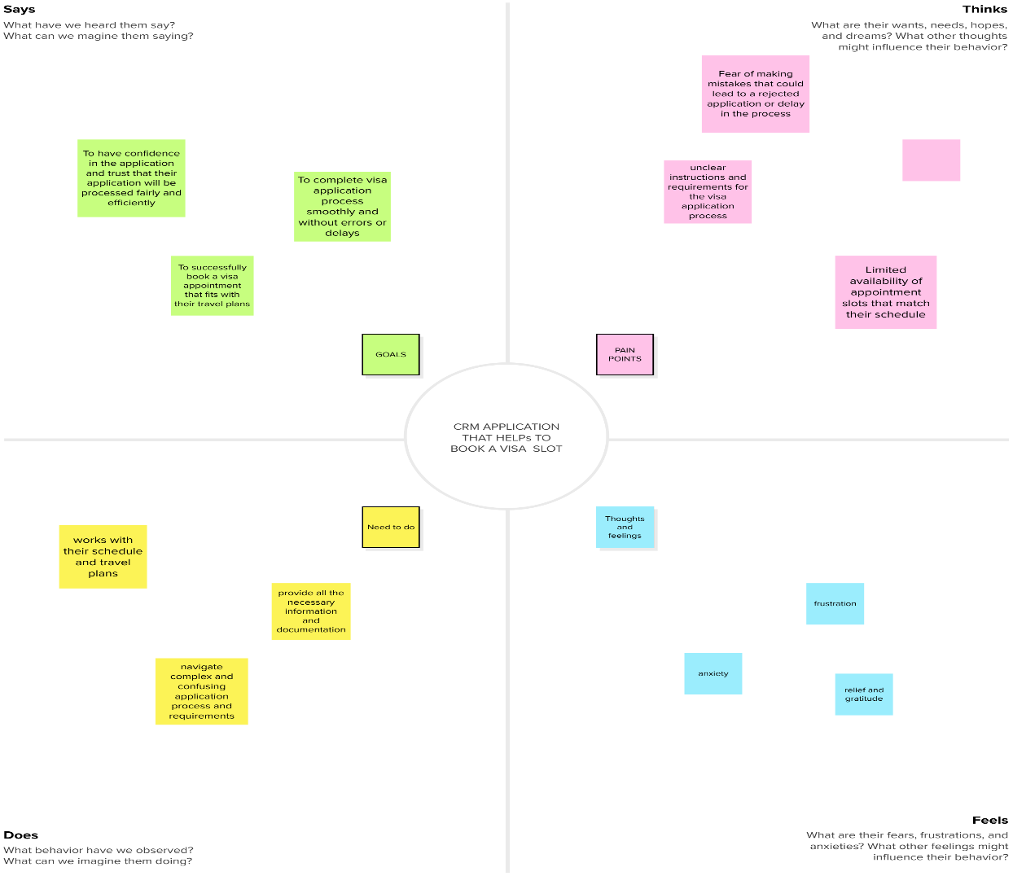

**IDEATION & BRAINSTORMING MAP**

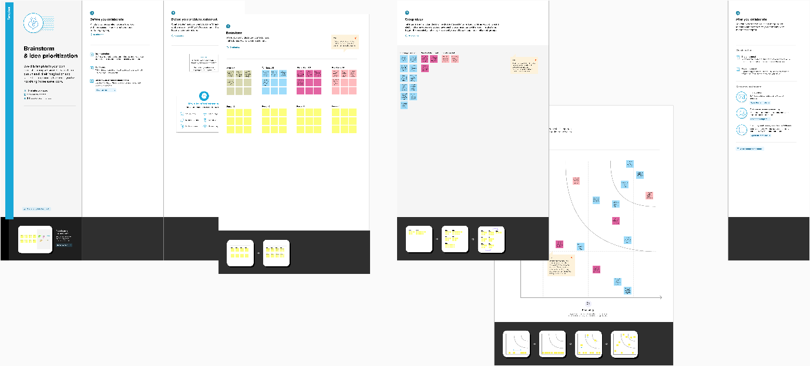

**RESULT**

|  |  |
| --- | --- |
| **Object name** | **Field in the Object** |
| Passport | |  |  | | --- | --- | | **Field Label** | **Data type** | | **Full Name**  **Passport Number**  **Contact Number** | **Visa slot** | |
| Visa slot | |  |  | | --- | --- | | **Field Label** | **Data type** | | **Location**  **Time**  **Visa Slot Number** | **Number** | |
| Payment | |  |  | | --- | --- | | **Field Label** | **Data type** | | **Payment**  **Card Number**  Transaction id | **Name** | |
| Reschedule/Cancel | |  |  | | --- | --- | | **Field Label** | **Data type** | | **Passport Number**  **Location**  **Cancel** | **Cancel** | |

**DATA MODEL**

**Activity & Screenshot**

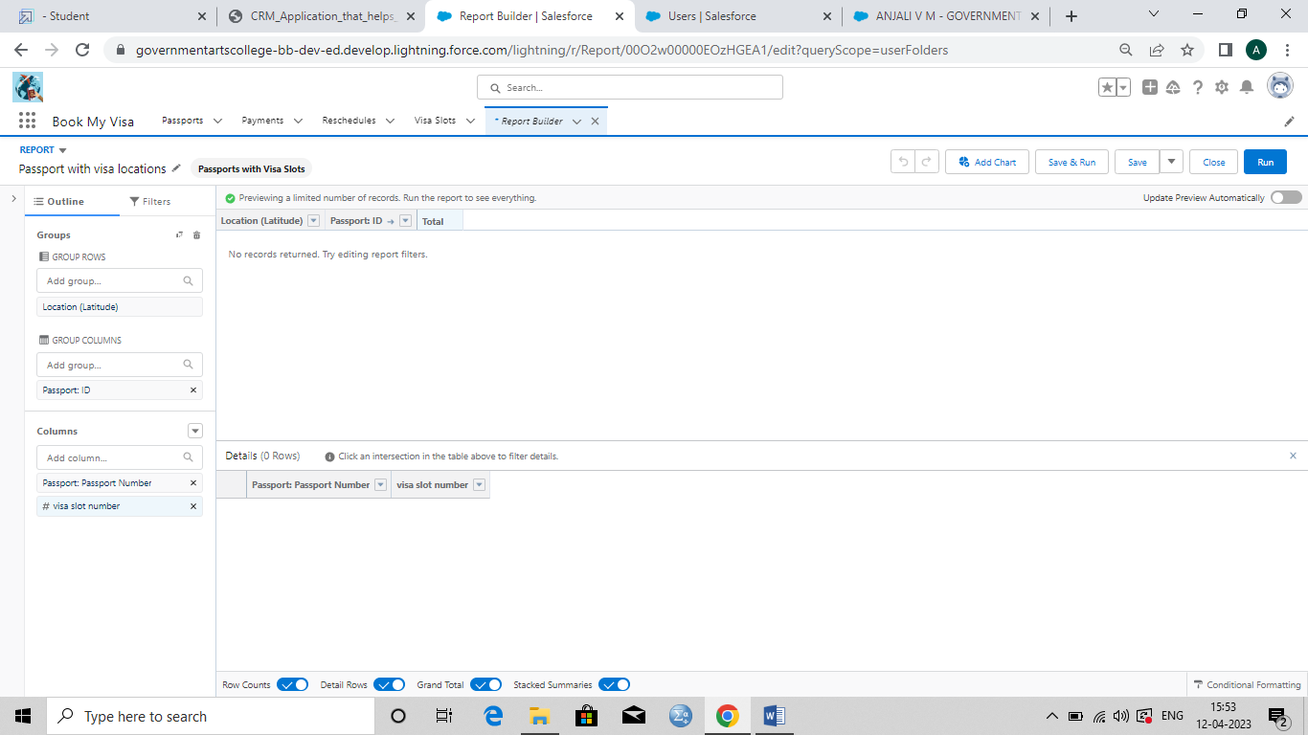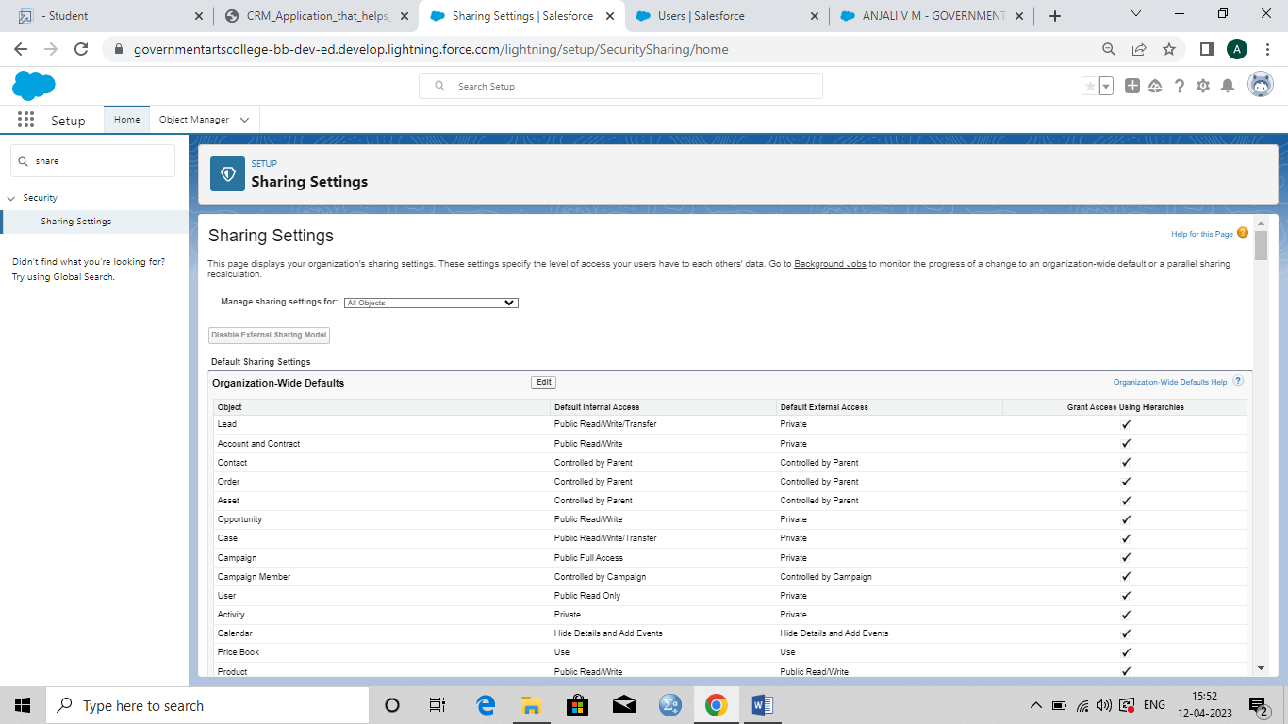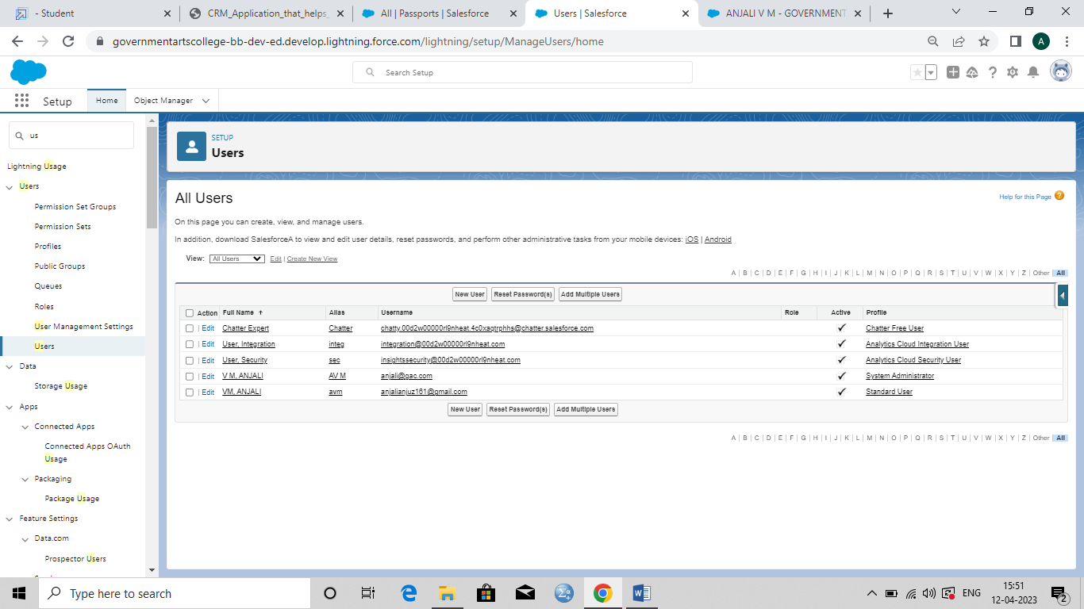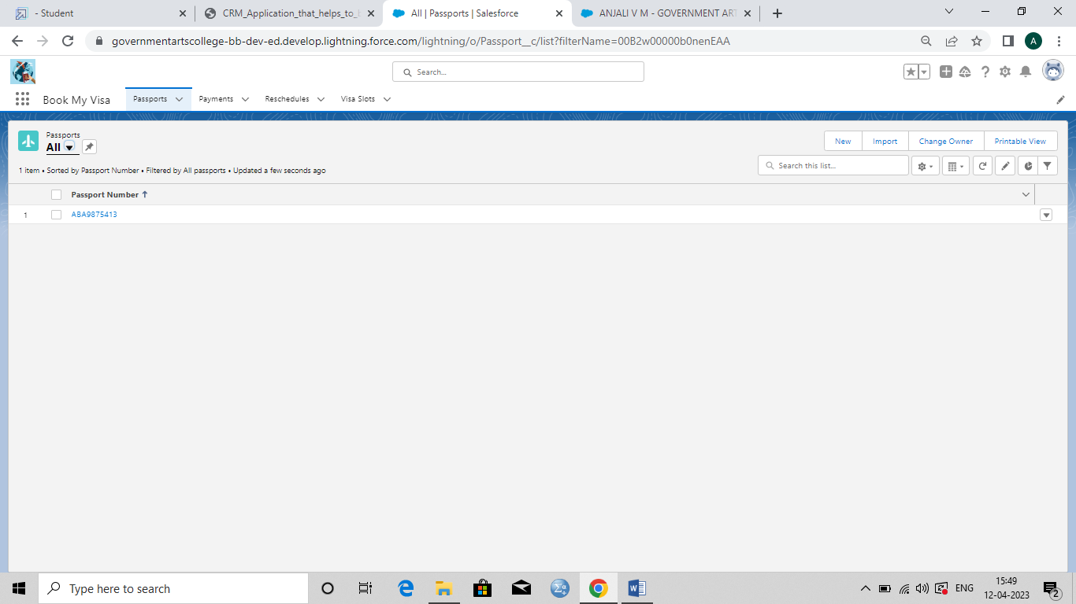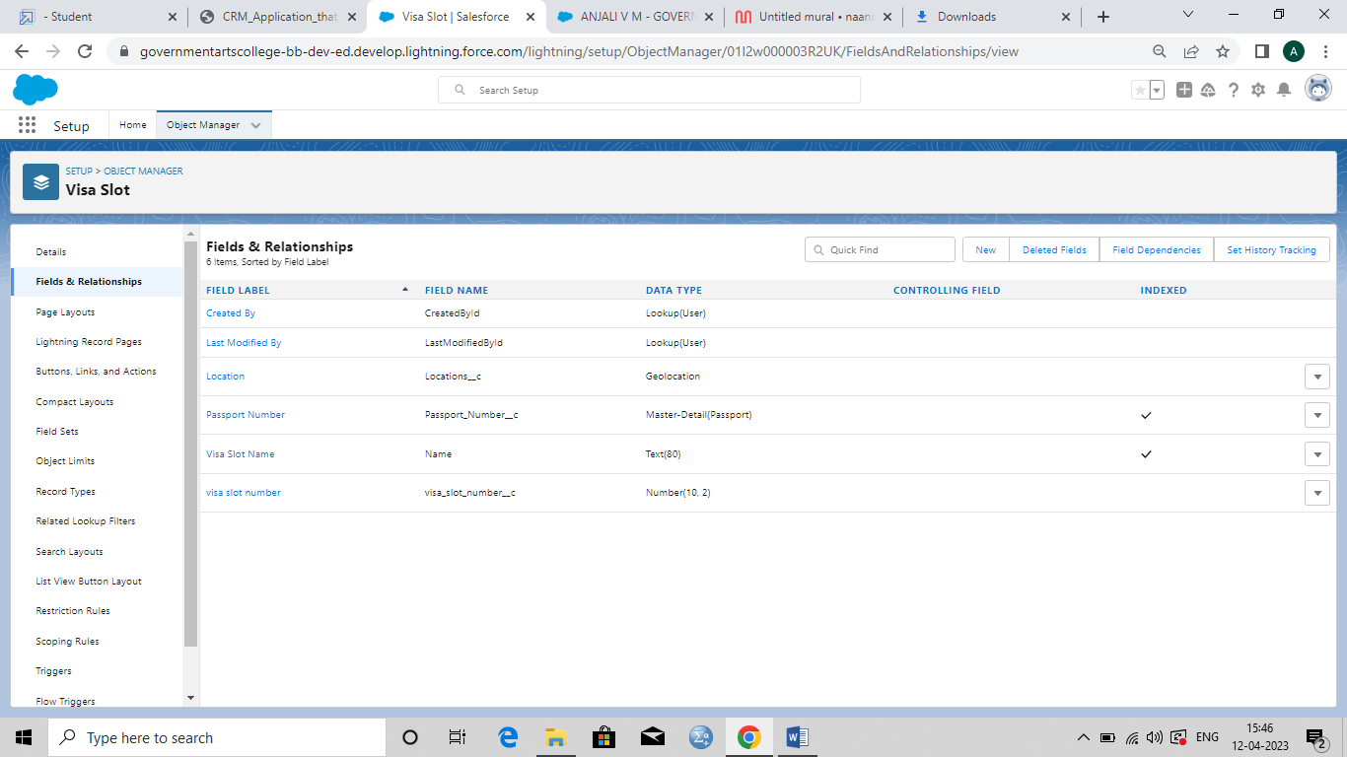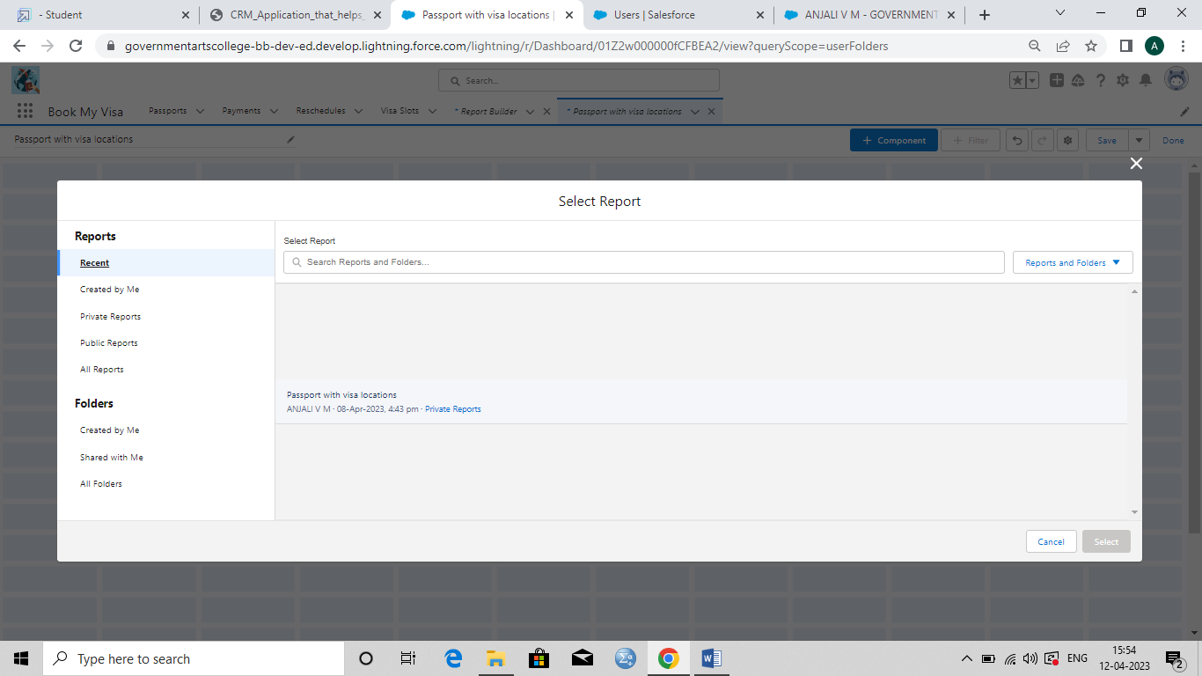

**Trailhead Profile Public URL**

**Team Lead -https://trailblazer.me/id/anjvm1**

**Team Member 1 -https://trailblazer.me/id/itamil3**

**Team Member 2-https://trailblazer.me/id/mah12**

**Team Member 3-https://trailblazer.me/id/trboy5**

**ADVANTAGES & DISADVANTAGES**

**ADVANTAGES**

**1. Time saving**

**2.Improved customers experiences**

**3.Incresed efficiency**

**DISADVANTAGES**

**1.Technical issues**

**2.Data security risks**

**3.Limited access**

**APPLICATIONS**

**1.Online booking system**

**2.Automated appointment reminders**

**3.Secure payments system**

**4.Tracking system**

**5.Customer support**

**CONCLUSION**

**To sum up ,a CRM application that helps customers book visa slots can greatly enhance the visa application process by providing a streamlined and efficient process for scheduling appointments. The application can include features such as an online booking system ,automated appointment reminders , a secure payment system ,a tracking system , and customer support to improve the overall customer experience . By using such an application ,customers can have a better experience booking their visa appointment , which can increase their satisfaction, while also reducing administrative workloads for the organization managing the visa application process.**

**FUTURE SCOPE**

**A CRM application that helps to book a visa slot can have a significant future scope, as it can address a major pain point for people who are applying for visas. Here are some potential benefits and future opportunities for such an application:**

**1.Improved user experience.**

**2.Increased Efficiency.**

**3.Enhanced security.**

**4.Expansion into other areas.**

**5.Integration with travel services.**